**Aim**: **Perform basic CLI commands to configure switch and router. CO4, CO6**

**Router Config:**

**Step 1:**

Here I have taken Router and PC to perform some commands and configure this two

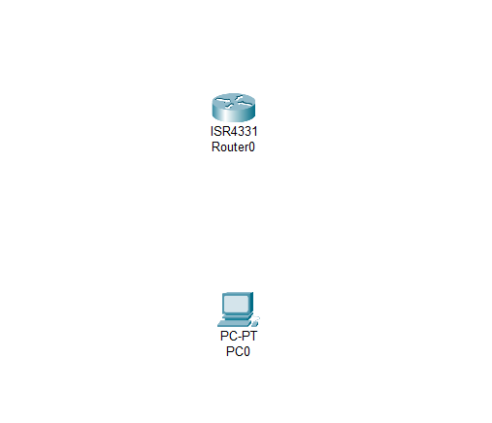

**Step 2:**

I am trying to connect this two devices through Console Cable

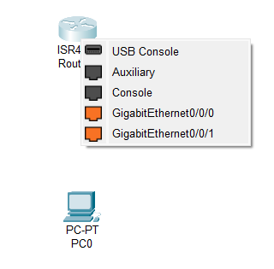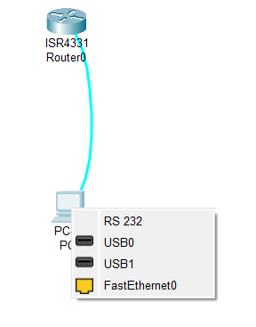

* When I have taken console cable and click on router so it will ask me for in which port I want to connect so we want to connect that in console so click on console
* For the same when I have click on PC then again ask for in which port you want to config so in that I have click on RS 232.

**Step 3:**

In below picture you can see that Router and PC are connect with console cable now I will try to configure them using some command.

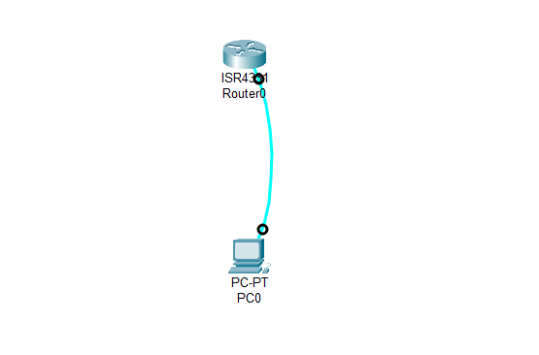

**Step 4:**

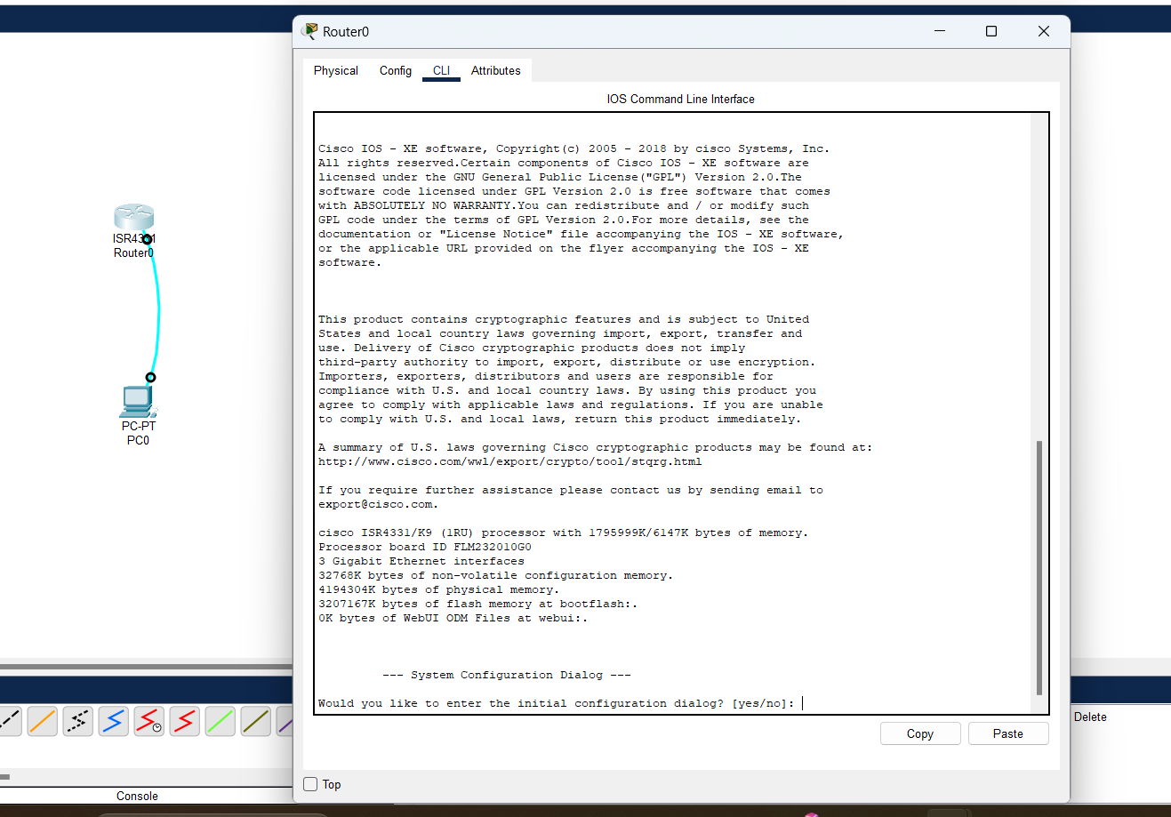

* Now to configure the router click on router and go to CLI tab
* In CLI tab when you start to configure router it will ask you that you want to initial configuration dialog so in that simply type No

**Step 5 :**

To get started click enter key

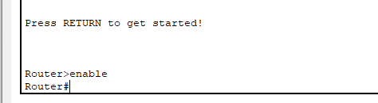

Now first command is

* enable : it is used to start a config and go to privilege mode. Once you perform this command you will do in privilege mode and get Router#.
* Shortcut of enable command is en.

**Step 6:**

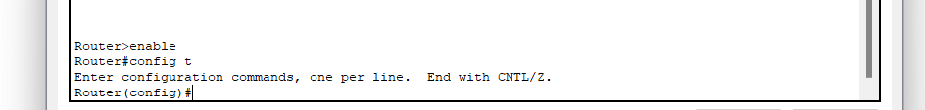

* Config t : this command is used to go privilaged mode to globe mode (Configuration mode)
* Config t is shortcut full command is configure terminal
* After perform this command you will get Router(config)#

**Step 7:**

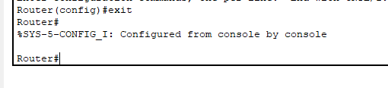

* If I want to move one mode to another mode for that perform exit command
* If you want to move config mode to privileged mode then simply execute exit command

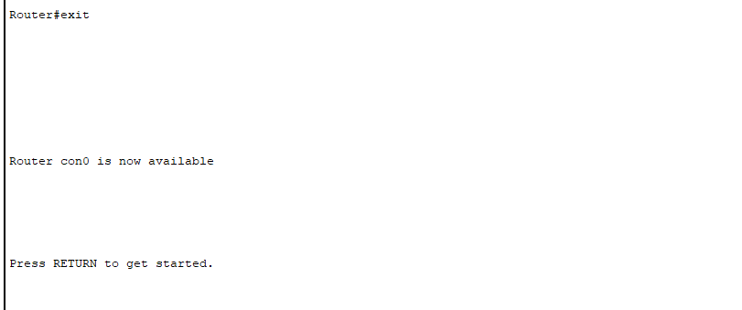

If you will perform twice exit command then your session must be end you want to again start from scratch.

**Step 8:**

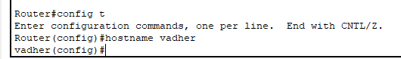

* If you want to change your router name or hostname so you can perform using hostname and then whatever name you want to put in that you will get that
* I have change from router to vadher so I have perform command like hostname vadher



If you again want to change then do the same task again

**Step 9:**

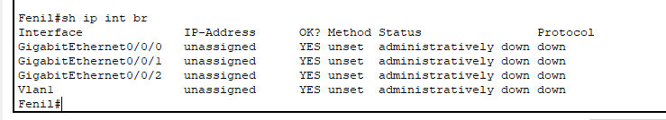

* Sh ip int br : this command use for to know all ip interface in our router
* Full command is show ip interface brief
* This command runs only and only privileged mode if I want to run this command in globle mode also so I want to perfrom this command : do sh ip int br add do keyword

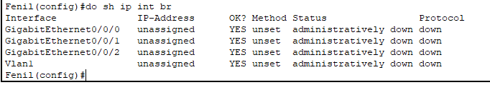

You will get the same output

**Switch Config :**

**Step 1:**

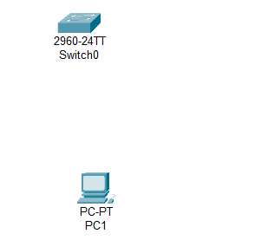

Here I have taken one switch and PC and I will execute some command to perform that

**Step : 2**

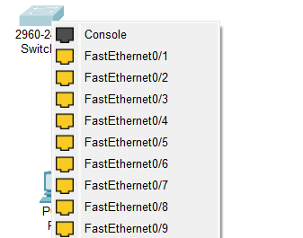 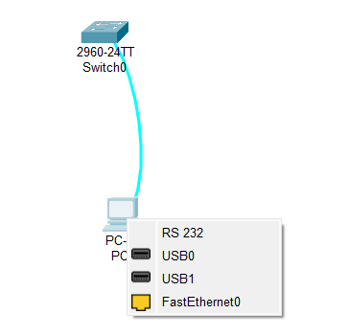

I have click on console in switch and in PC I have click on RS 232 to connect console cable

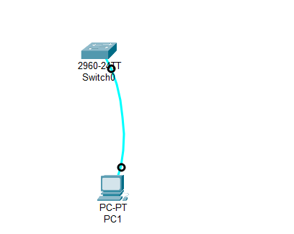

Switch and PC connect through Console cable.

**Step : 3**

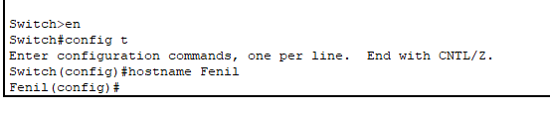

* In this I have execute the same command which I have execute in router configuration
* Enable
* Config t
* Hostname Fenil

**Step 4 :**



Interface vlan 1 : this command take me in config-if#

**Step 5 :**



I have execute this command : ip address 192.168.1.2 255.255.255.0

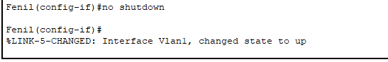

* I have execute this command : no shutdown
* Interface vlan1 , changed state to up using this command

**Step 6:**

****I have execute this command : ip default-gateway 192.168.1.1

**Conclusion:**

In conclusion, configuring a Cisco switch and router using CLI commands involves connecting to the device, entering the appropriate configuration modes, and setting basic parameters such as hostname, IP addresses, and routing information. By following these steps, you can establish a foundational network setup, enabling effective communication and management within your network.

1. **Router Configuration**:

* **Enable Privileged Mode**: Entered privileged mode using the enable command.
* **Global Configuration Mode**: Accessed global configuration mode with the config t command.
* **Exiting Modes**: Used the exit command to switch between different configuration modes.
* **Hostname Configuration**: Changed the router hostname to "vadher" using the hostname vadher command.
* **Interface Information**: Displayed IP interface information using show ip interface brief or sh ip int br command.

1. **Switch Configuration**:

* **Connection Setup**: Connected the switch and PC through a console cable.
* **Basic Commands**: Applied basic configuration commands similar to the router (enable, config t, hostname).
* **VLAN Configuration**: Entered interface VLAN configuration mode with the interface vlan 1 command.
* **IP Address Assignment**: Assigned an IP address to VLAN 1 using ip address 192.168.1.2 255.255.255.0.
* **Interface Activation**: Brought the interface up using the no shutdown command.
* **Default Gateway Configuration**: Set the default gateway with ip default-gateway 192.168.1.1.

By following these steps, the basic configuration for both the router and switch was completed, ensuring they are properly set up for network communication.